This document will walk you through how to get some individual metrics on your post counts via PowerBI desktop.

1. Download PowerBI Desktop from Microsoft Store (won’t work on Mac Computers as there is no Desktop app for Mac at this point unfortunately)
2. Save the .pbix file to your computer
3. Open PowerBI desktop
4. Open the .pbix file (Teams Individual Analytics)
5. Navigate to Transform Data > Data source settings (You could also just hit Refresh next to Transform Data and you will be prompted to enter your credentials)

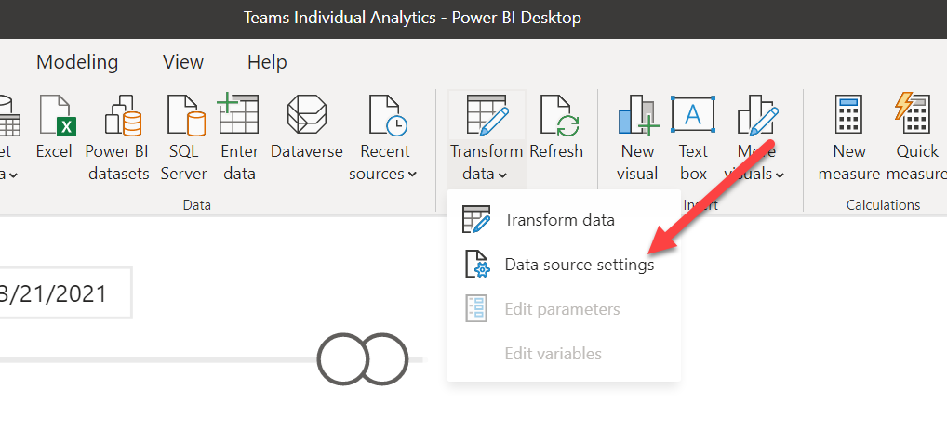

1. Select Edit Permissions

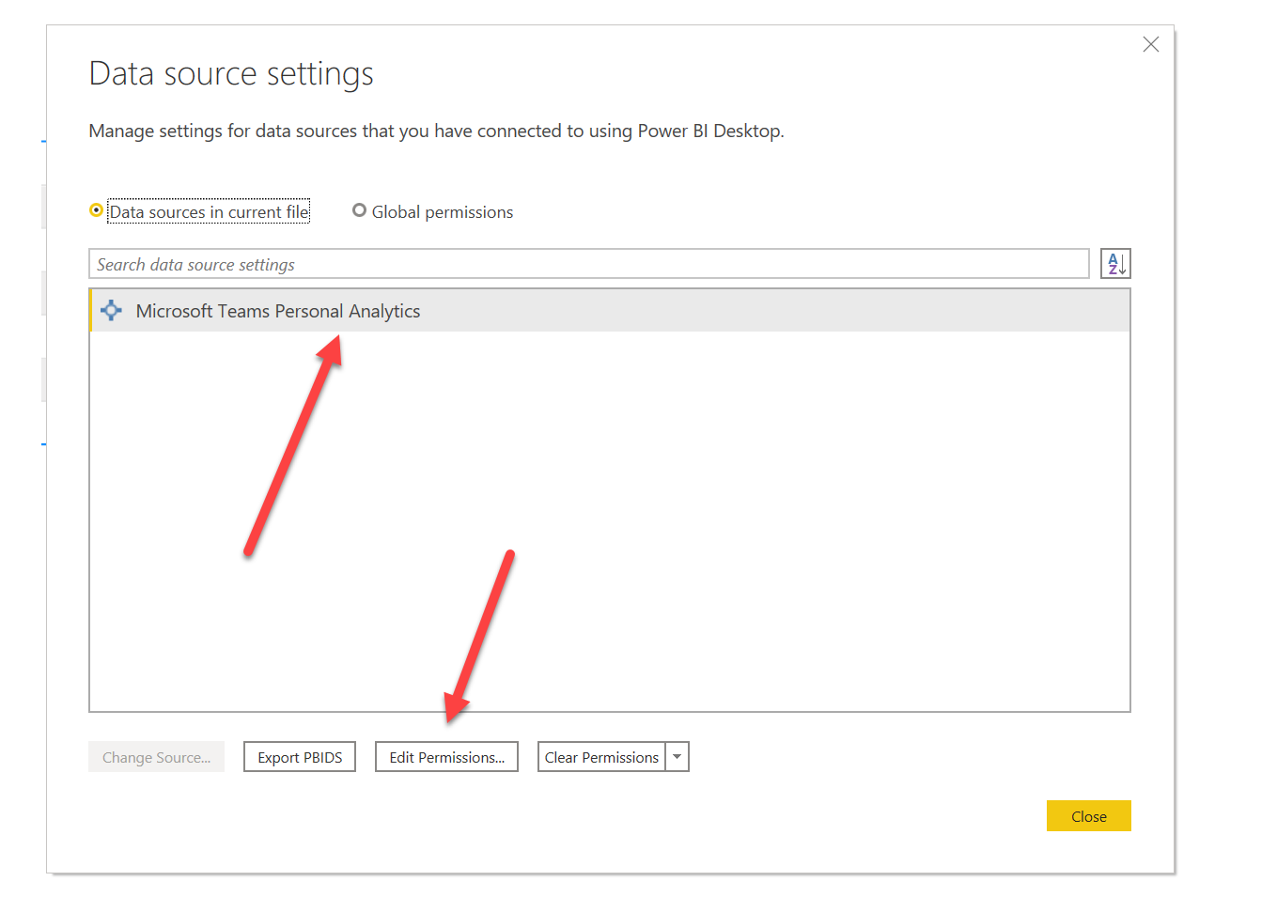

1. Select Edit

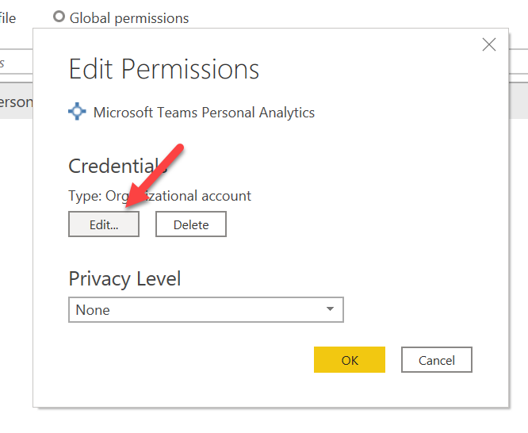

1. Sign in as a different user – log in with your Bellevue credentials



1. Apply changes or select refresh to receive your metrics

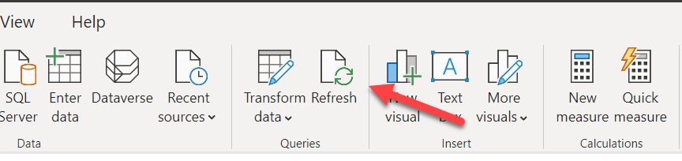

1. This is the dashboard that will be available with your posts/replies/totals by date. You will need to filter the date range to the current week you want to look at. **Note: The data saved in the dashboard view when you download the file is mine – not your own, you need to refresh and enter your credentials to see your updated metrics.**

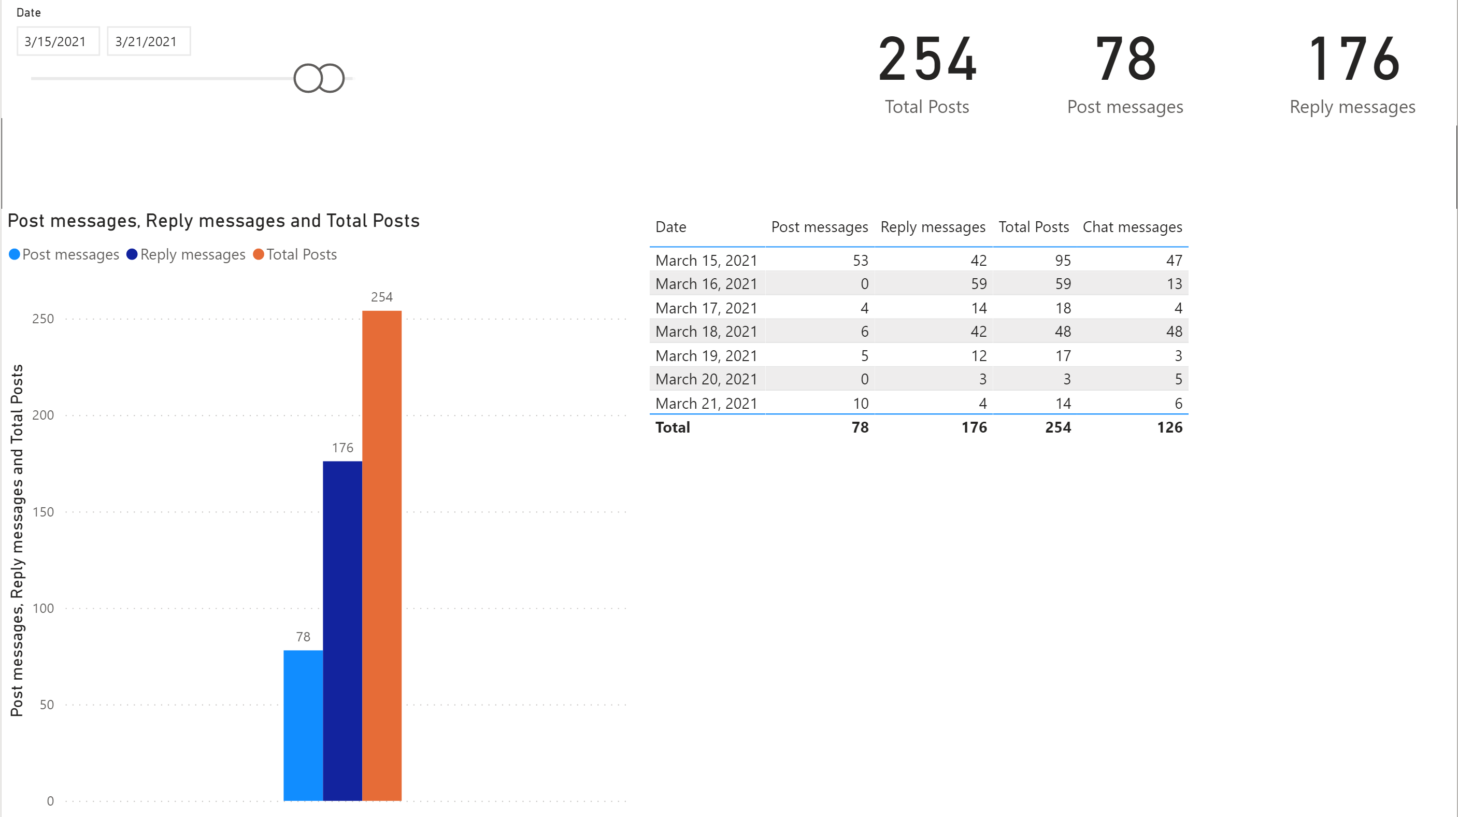

Fields:

* Post Messages – If you created an original post
* Reply Messages – If you responded to another post
* Total Posts – Sum of Post Messages & Reply Messages
* Chat Messages – Private Chats – not included in grading total

**NOTE: Currently this connector does not distinguish between channels or teams – so you will want to make sure that if you have two courses, you realize that the total is for ALL communication via Teams. Hopefully this is updated in the near future, but right now, this is a combination of all your communication activity across Teams. This is a Microsoft Limitation, not something Bellevue can modify.**